

Name
Talha Abdullah Bangyal
Roll Number
SU92-BAIFM-F25-002
Section
BAI-5B
Subject
Computer Network (Lab)
Submitted To
Yusra Shafique

Task 1

Router 1
R1> enable
R1

interface GigabitEthernet0/0
ip address 192.168.1.1 255.255.255.0
no shutdown
exit

interface GigabitEthernet0/1
ip address 10.0.0.1 255.255.255.252
no shutdown
exit

router rip
version 2
no auto-summary
network 192.168.1.0
network 10.0.0.0
exit

end
write memory

Router 2
R2> enable
R2

interface GigabitEthernet0/0
ip address 192.168.2.1 255.255.255.0
no shutdown
exit

interface GigabitEthernet0/1
ip address 10.0.0.2 255.255.255.252
no shutdown
exit

router rip
version 2
no auto-summary
network 192.168.2.0
network 10.0.0.0
exit

end
write memory

Output
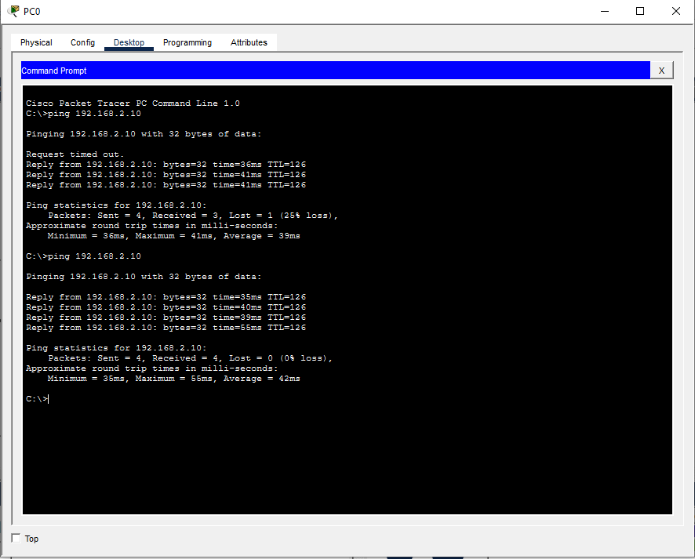

Task 2

Router 1
enable
configure terminal

interface GigabitEthernet0/0
ip address 192.168.10.1 255.255.255.0
no shutdown
exit

interface Serial0/0/0
ip address 10.0.0.1 255.255.255.252
clock rate 64000
no shutdown
exit

router rip
version 2
no auto-summary
network 192.168.10.0
network 10.0.0.0
exit

end
write memory

Router 2
enable
configure terminal

interface GigabitEthernet0/0
ip address 192.168.20.1 255.255.255.0
no shutdown
exit

interface Serial0/0/0
ip address 10.0.0.2 255.255.255.252
no shutdown
exit

interface Serial0/0/1
ip address 10.0.0.5 255.255.255.252
clock rate 64000
no shutdown
exit

router rip
version 2
no auto-summary
network 192.168.20.0
network 10.0.0.0
exit

end
write memory

Router 3
enable
configure terminal

interface GigabitEthernet0/0
ip address 192.168.30.1 255.255.255.0
no shutdown
exit

interface Serial0/0/0
ip address 10.0.0.6 255.255.255.252
no shutdown
exit

router rip
version 2
no auto-summary
network 192.168.30.0
network 10.0.0.0
exit

end
write memory

